**B. Prabhakar**

**======================**

**201505618**

**======================**

**Assignment II**

**Question 1:**

**Question 2:**

**Single-sample Perceptron**

prabhakar@Code$ *python Algo_implemented.py SingleSamplePerceptron*

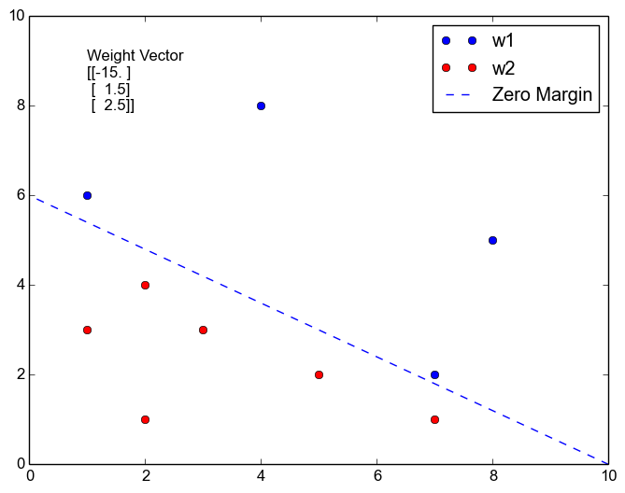

**Weight Vector:**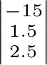

**Question 3:**

**Single-sample Perceptron with Margin**

*prabhakar@Code$ python Algo_implemented.py SingleSamplePerceptronWithMargin*

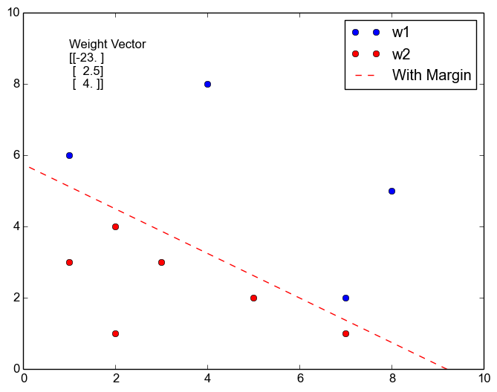

***Weight Vector:***

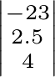

**Question 4:**

**Relaxation algorithm with margin**

*prabhakar@Code$ python Algo_implemented.py Relaxation*

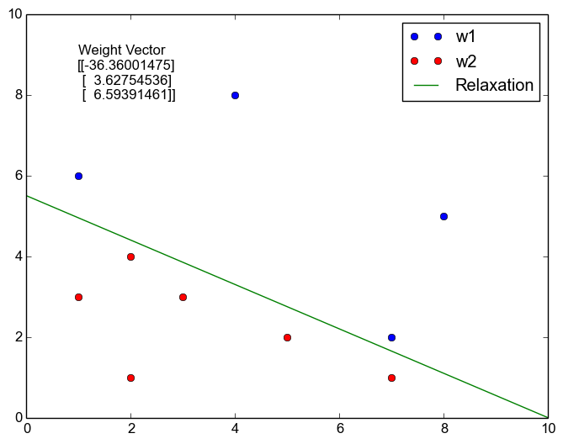

***Weight Vector:***

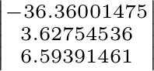

**Question 5:**

**Widrow-Hoff or Least Mean Squared (LMS) Rule**

*prabhakar@Code$ python Algo_implemented.py LMS*

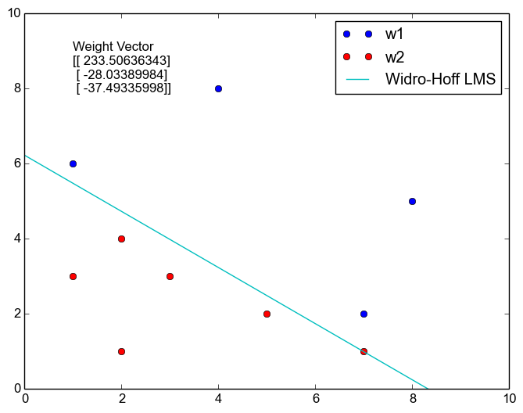

***Weight Vector:***

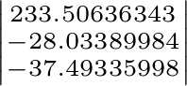

**Question A:**

**Widrow-Hoff or Least Mean Squared (LMS) Rule**

*prabhakar@Code$ python Algo_implemented.py all*

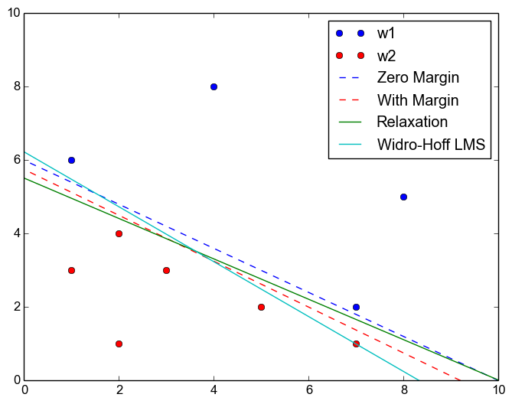

***Weight Vector:***

Single Sample Perceptron

========================

[[-15. ]

[ 1.5]

[ 2.5]]

Single Sample Perceptron With Margin

====================================

[[-23. ]

[ 2.5]

[ 4. ]]

Single Sample Perceptron With Relaxation procedure

==================================================

[[-36.36001475]

[ 3.62754536]

[ 6.59391461]]

Widro-Hoff LMS

==============

[[ 233.50636343]

[ -28.03389984]

[ -37.49335998]]

**Question: 7**

**Practical Exercise: B**

**Adding new samples(non-linearly separable) to the training set**

*prabhakar@Code$ python Algo_implemented_with_new_data.py*

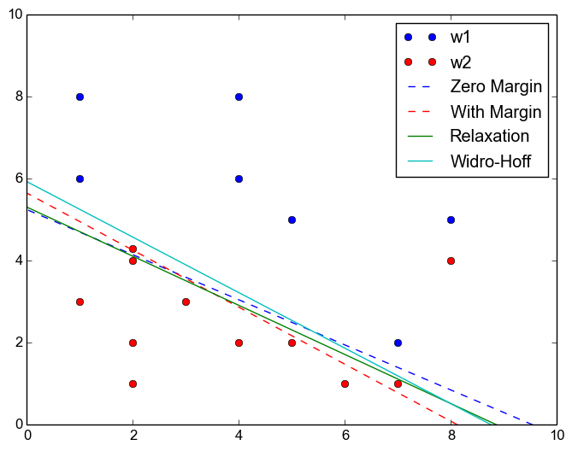

***Weight Vector:***

*Single Sample Perceptron*

*========================*

*[[-52.5]*

*[ 5.5]*

*[ 10. ]]*

*Single Sample Perceptron With Margin*

*====================================*

*[[-65. ]*

*[ 8. ]*

*[ 11.5]]*

*Single Sample Perceptron With Relaxation procedure*

*==================================================*

*[[ -2.45150385e+18]*

*[ 2.76562229e+17]*

*[ 4.61585832e+17]]*

*Widro-Hoff LMS*

*==============*

*[[ 232.07787943]*

*[ -26.48489166]*

*[ -39.11830465]]*

**The nature of the solution found in**

* **Single-sample perceptron**
* **Single-sample perceptron with margin**
* **Relaxation algorithm with margin**

*As the data is not linearly separable, all the above three algorithms go into an infinite loop. The cause for this behavior is that the above algorithms are trying to find a straight line or an hyperplane that classifies the two classes ω1 and ω2. While trying to do so, always at least one training sample of either or both the classes remains miss-classified. In order to correct it the above algorithm updates the weight vector, which consequently results in the mis-classification of other points. Thus, the above algorithms enter into an infinite loop. The loop is programatically braked after a fixed number of iterations.*

* ***Widrow-Hoff****This algorithm converges to a weight vector which produces minimal error with respect to the classification. The convergence time depends on the initial weight vector and also the learning rate that is chosen.*

|  |  |
| --- | --- |
| **Comparison Table** | |
| Single-sample perceptron | 88% |
| Single-sample perceptron with margin | 83% |
| Relaxation algorithm with margin | 88% |
| *Widrow-Hoff* | 94% |

**Practical Exercise C:**

***Relation between the initial weight vector and the convergence time***

* **Single-sample perceptron**
* **Single-sample perceptron with margin**
* **Relaxation algorithm with margin**For the above algorithms, if the data is linearly separable the algorithm convergence time is found to be finite irrespective of the initial values of the weight vectors. However, if the data is not linearly separable the convergence time is not finite.
* ***Widrow-Hoff***The algorithm convergence time always changes with respect to the initial values of the weight vectors. If the initial values of the weight vectors in closer to the actual values of the weight vector(that we are supposed to obtain), the algorithm converges faster. On the other hand if the initial values are far away from the actual value of the weight vector, the algorithm takes significantly large time to converge.

**Practical Exercise D:**

***Effect of adding different margins on the final solution and the convergence-time for algorithms***

* **Single-sample perceptron**
* **Single-sample perceptron with margin**
* **Relaxation algorithm with margin**As the margin increases the convergence time is significantly affected for the above algorithms, provided the algorithm always terminates with correct decision boundary.  
  If we impose a rule stating that the algorithm must terminate after certain number of iterations, the execution time will be still high, however we might not get the accurate or correct decision boundary.
* **Widrow-Hoff**As the margin changes, the algorithm always terminates with almost same decision boundary without any significant change in the convergence time.

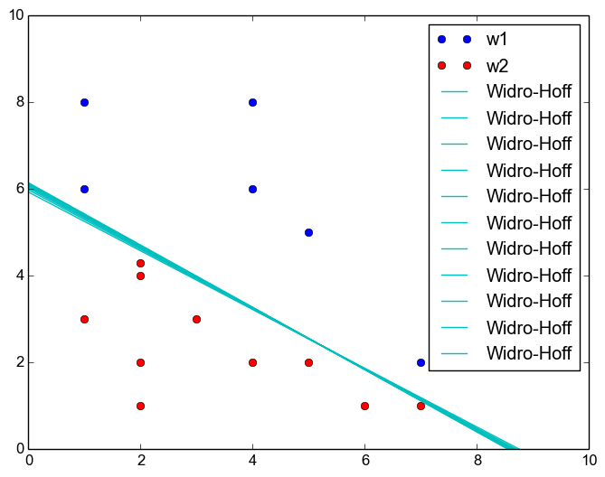

**Question 6:**

***Thus there exists any data-set for which the LMS and perceptron always turns out to be in-line(aligned) or different?***

No.

In case of linearly separable data, the solution obtained by both the algorithms will be aligned with each other.

In case of linearly non-separable data, the perceptron algorithm will never converge. So, the depending on the point at which we break the algorithm, the solution could be aligned or different from that of the one obtained from the LMS rule.

Source Code

**Algo_Implemented.py**

"""

Questions answered:

===================

Implement the following algorithms:

2. Single-sample perceptron

3. Single-sample perceptron with margin

4. Relaxation algorithm with margin

5. Widrow-Hoff or Least Mean Squared (LMS) Rule

A. In each case, plot the data points in a graph (e.g. Circle: class= 1 and Cross: class= 2 ) and

also show the weight vector a learnt from all of the above algorithms in the same graph

(labeling clearly to distinguish different solutions).

"""

#!/usr/bin/python

import sys

from matplotlib import pyplot as ppl

import numpy as np

w1 = [(1, 6), (7, 2), (8, 9), (9, 9), (4, 8), (8, 5)]

w2 = [(2, 1), (3, 3), (2, 4), (7, 1), (1, 3), (5, 2)]

w1_x = [ i[0] for i in w1 ]

w1_y = [ i[1] for i in w1 ]

w2_x = [ i[0] for i in w2 ]

w2_y = [ i[1] for i in w2 ]

augmented_Tain_set = [ np.array( [[1], [i[0]], [i[1]]] ) for i in w1 ]

augmented_Tain_set.extend( [ np.array( [[-1], [-i[0]], [-i[1]]] ) for i in w2 ] )

axes = ppl.gca()

axes.set_xlim( [0, max(max(w1_x),max(w2_x)) +1] )

axes.set_ylim( [0, max(max(w1_y),max(w2_y))+1] )

ppl.plot( w1_x, w1_y, "bo", label="w1" )

ppl.plot( w2_x, w2_y, "ro", label="w2" )

def getWeightsForPerceptron( b, perceptronType ):

if perceptronType=="Widro-Hoff LMS":

wt_vector = np.array( [[230], [-57.5], [-78.3]] ) # Column Vector

else:

wt_vector = np.array( [[0.5], [-0.5], [1.5]] ) # Column Vector

i=0

iteration=0

while i<len(augmented_Tain_set):

y = wt_vector.transpose().dot( augmented_Tain_set[i] )

if perceptronType=="Widro-Hoff LMS":

etha = 0.01

wt_vector += etha * ( b - wt_vector.transpose().dot(augmented_Tain_set[i]) ) * augmented_Tain_set[i];

i+=1;

elif y<=b:

if perceptronType=="Relaxation":

etha = 2.5

wt_vector += etha * ((float((b - y)) / sum([j[0]*j[0] for j in augmented_Tain_set[i]])) * augmented_Tain_set[i])

else:

etha = 0.5

wt_vector += etha*augmented_Tain_set[i];

i=0;

else:

i+=1;

iteration+=1

if iteration > 100000:

break;

return wt_vector;

"""

Single Sample Perceptron

"""

if len(sys.argv)!= 2:

print "Pass the arguments"

print "SingleSamplePerceptron"

print "SingleSamplePerceptronWithMargin"

print "Relaxation"

print "LMS"

if sys.argv[1] == "SingleSamplePerceptron" or sys.argv[1] == "all":

wt_vector = getWeightsForPerceptron( 0, "SingleSamplePerceptron" );

ppl.plot( [-float(wt_vector[0][0]) / float(wt_vector[1][0]), 0],

[0, -float(wt_vector[0][0]) / float(wt_vector[2][0])], "b--", label="Zero Margin")

print "Single Sample Perceptron"

print "========================"

print wt_vector;

if sys.argv[1] == "SingleSamplePerceptronWithMargin" or sys.argv[1] == "all":

"""

Single Sample Perceptron With Margin

"""

wt_vector = getWeightsForPerceptron( 1, "SingleSamplePerceptronWithMargin" );

ppl.plot( [-float(wt_vector[0][0]) / float(wt_vector[1][0]), 0],

[0, -float(wt_vector[0][0]) / float(wt_vector[2][0])], "r--", label="With Margin")

print "Single Sample Perceptron With Margin"

print "===================================="

print wt_vector;

if sys.argv[1] == "Relaxation" or sys.argv[1] == "all":

"""

Single Sample Perceptron With Relaxation procedure

"""

wt_vector = getWeightsForPerceptron( 1, "Relaxation" );

ppl.plot( [-float(wt_vector[0][0])/float(wt_vector[1][0]), 0],

[0, -float(wt_vector[0][0]) / float(wt_vector[2][0])], "g-", label="Relaxation")

print "Single Sample Perceptron With Relaxation procedure"

print "=================================================="

print wt_vector;

if sys.argv[1] == "LMS" or sys.argv[1] == "all":

"""

Widro-Hoff LMS

"""

wt_vector = getWeightsForPerceptron( 1, "Widro-Hoff LMS" );

ppl.plot( [-float(wt_vector[0][0])/float(wt_vector[1][0]), 0],

[0, -float(wt_vector[0][0]) / float(wt_vector[2][0])], "c-", label="Widro-Hoff LMS")

print "Widro-Hoff LMS"

print "=============="

print wt_vector;

ppl.legend()

if sys.argv[1] != "all":

ppl.text(1, max(max(w1_y),max(w2_y)), "Weight Vector" )

ppl.text(1, max(max(w1_y),max(w2_y))-1.1, wt_vector )

# ppl.show();

ppl.savefig('/home/prabhakar/IIIT-H_current/Sem 2/SMAI/Assignments/2/201505618_Assignment2/'+

str(sys.argv[1])+'.png', bbox_inches='tight')

**Algo_implemented_with_new_data.py**

"""

Questions answered:

===================

B. Create a test set comprising three more data samples (y i ) for each class and test your

implementation by computing for each of the test samples the output (class label) predicted

by the respective algorithm. Create a comparison table listing test set accuracies of each of

the above algorithms.

"""

#!/usr/bin/python

import sys

from matplotlib import pyplot as ppl

import numpy as np

w1 = [(1, 6), (7, 2), (8, 9), (9, 9), (4, 8), (8, 5)]

w2 = [(2, 1), (3, 3), (2, 4), (7, 1), (1, 3), (5, 2), (8, 4)]

# Adding new data elements

w1.extend( [(4, 6), (1, 8), (5, 5)] )

w2.extend( [(2, 2), (4, 2), (6, 1), (2, 4.3)] )

w1_x = [ i[0] for i in w1 ]

w1_y = [ i[1] for i in w1 ]

w2_x = [ i[0] for i in w2 ]

w2_y = [ i[1] for i in w2 ]

augmented_Tain_set = [ np.array( [[1], [i[0]], [i[1]]] ) for i in w1 ]

augmented_Tain_set.extend( [ np.array( [[-1], [-i[0]], [-i[1]]] ) for i in w2 ] )

axes = ppl.gca()

axes.set_xlim( [0, max(max(w1_x),max(w2_x)) +1] )

axes.set_ylim( [0, max(max(w1_y),max(w2_y))+1] )

ppl.plot( w1_x, w1_y, "bo", label="w1" )

ppl.plot( w2_x, w2_y, "ro", label="w2" )

def getWeightsForPerceptron( b, perceptronType ):

if perceptronType=="Widro-Hoff LMS":

wt_vector = np.array( [[230], [-57.5], [-78.3]] ) # Column Vector

else:

wt_vector = np.array( [[0.5], [-0.5], [1.5]] ) # Column Vector

i=0

iteration=0

while i<len(augmented_Tain_set):

y = wt_vector.transpose().dot( augmented_Tain_set[i] )

if perceptronType=="Widro-Hoff LMS":

etha = 0.01

wt_vector += etha * ( b - wt_vector.transpose().dot(augmented_Tain_set[i]) ) * augmented_Tain_set[i];

i+=1;

elif y<=b:

if perceptronType=="Relaxation":

etha = 2.5

wt_vector += etha * ((float((b - y)) / sum([j[0]*j[0] for j in augmented_Tain_set[i]])) * augmented_Tain_set[i])

else:

etha = 0.5

wt_vector += etha*augmented_Tain_set[i];

i=0;

else:

i+=1;

iteration+=1

if iteration > 100000:

break;

return wt_vector;

"""

Single Sample Perceptron

"""

wt_vector = getWeightsForPerceptron( 0, "singleSamplePerceptron" );

ppl.plot( [-float(wt_vector[0][0]) / float(wt_vector[1][0]), 0],

[0, -float(wt_vector[0][0]) / float(wt_vector[2][0])], "b--", label="Zero Margin")

print "Single Sample Perceptron"

print "========================"

print wt_vector;

"""

Single Sample Perceptron With Margin

"""

wt_vector = getWeightsForPerceptron( 1, "SingleSamplePerceptronWithMargin" );

ppl.plot( [-float(wt_vector[0][0]) / float(wt_vector[1][0]), 0],

[0, -float(wt_vector[0][0]) / float(wt_vector[2][0])], "r--", label="With Margin")

print "Single Sample Perceptron With Margin"

print "===================================="

print wt_vector;

"""

Single Sample Perceptron With Relaxation procedure

"""

wt_vector = getWeightsForPerceptron( 1, "Relaxation" );

ppl.plot( [-float(wt_vector[0][0])/float(wt_vector[1][0]), 0],

[0, -float(wt_vector[0][0]) / float(wt_vector[2][0])], "g-", label="Relaxation")

print "Single Sample Perceptron With Relaxation procedure"

print "=================================================="

print wt_vector;

"""

Widro-Hoff

"""

wt_vector = getWeightsForPerceptron( 1, "Widro-Hoff LMS" );

ppl.plot( [-float(wt_vector[0][0])/float(wt_vector[1][0]), 0],

[0, -float(wt_vector[0][0]) / float(wt_vector[2][0])], "c-", label="Widro-Hoff")

print "Widro-Hoff LMS"

print "=============="

print wt_vector;

ppl.legend()

ppl.savefig('/home/prabhakar/IIIT-H_current/Sem 2/SMAI/Assignments/2/201505618_Assignment2/'+

str(sys.argv[0])+'.png', bbox_inches='tight')

# ppl.show();